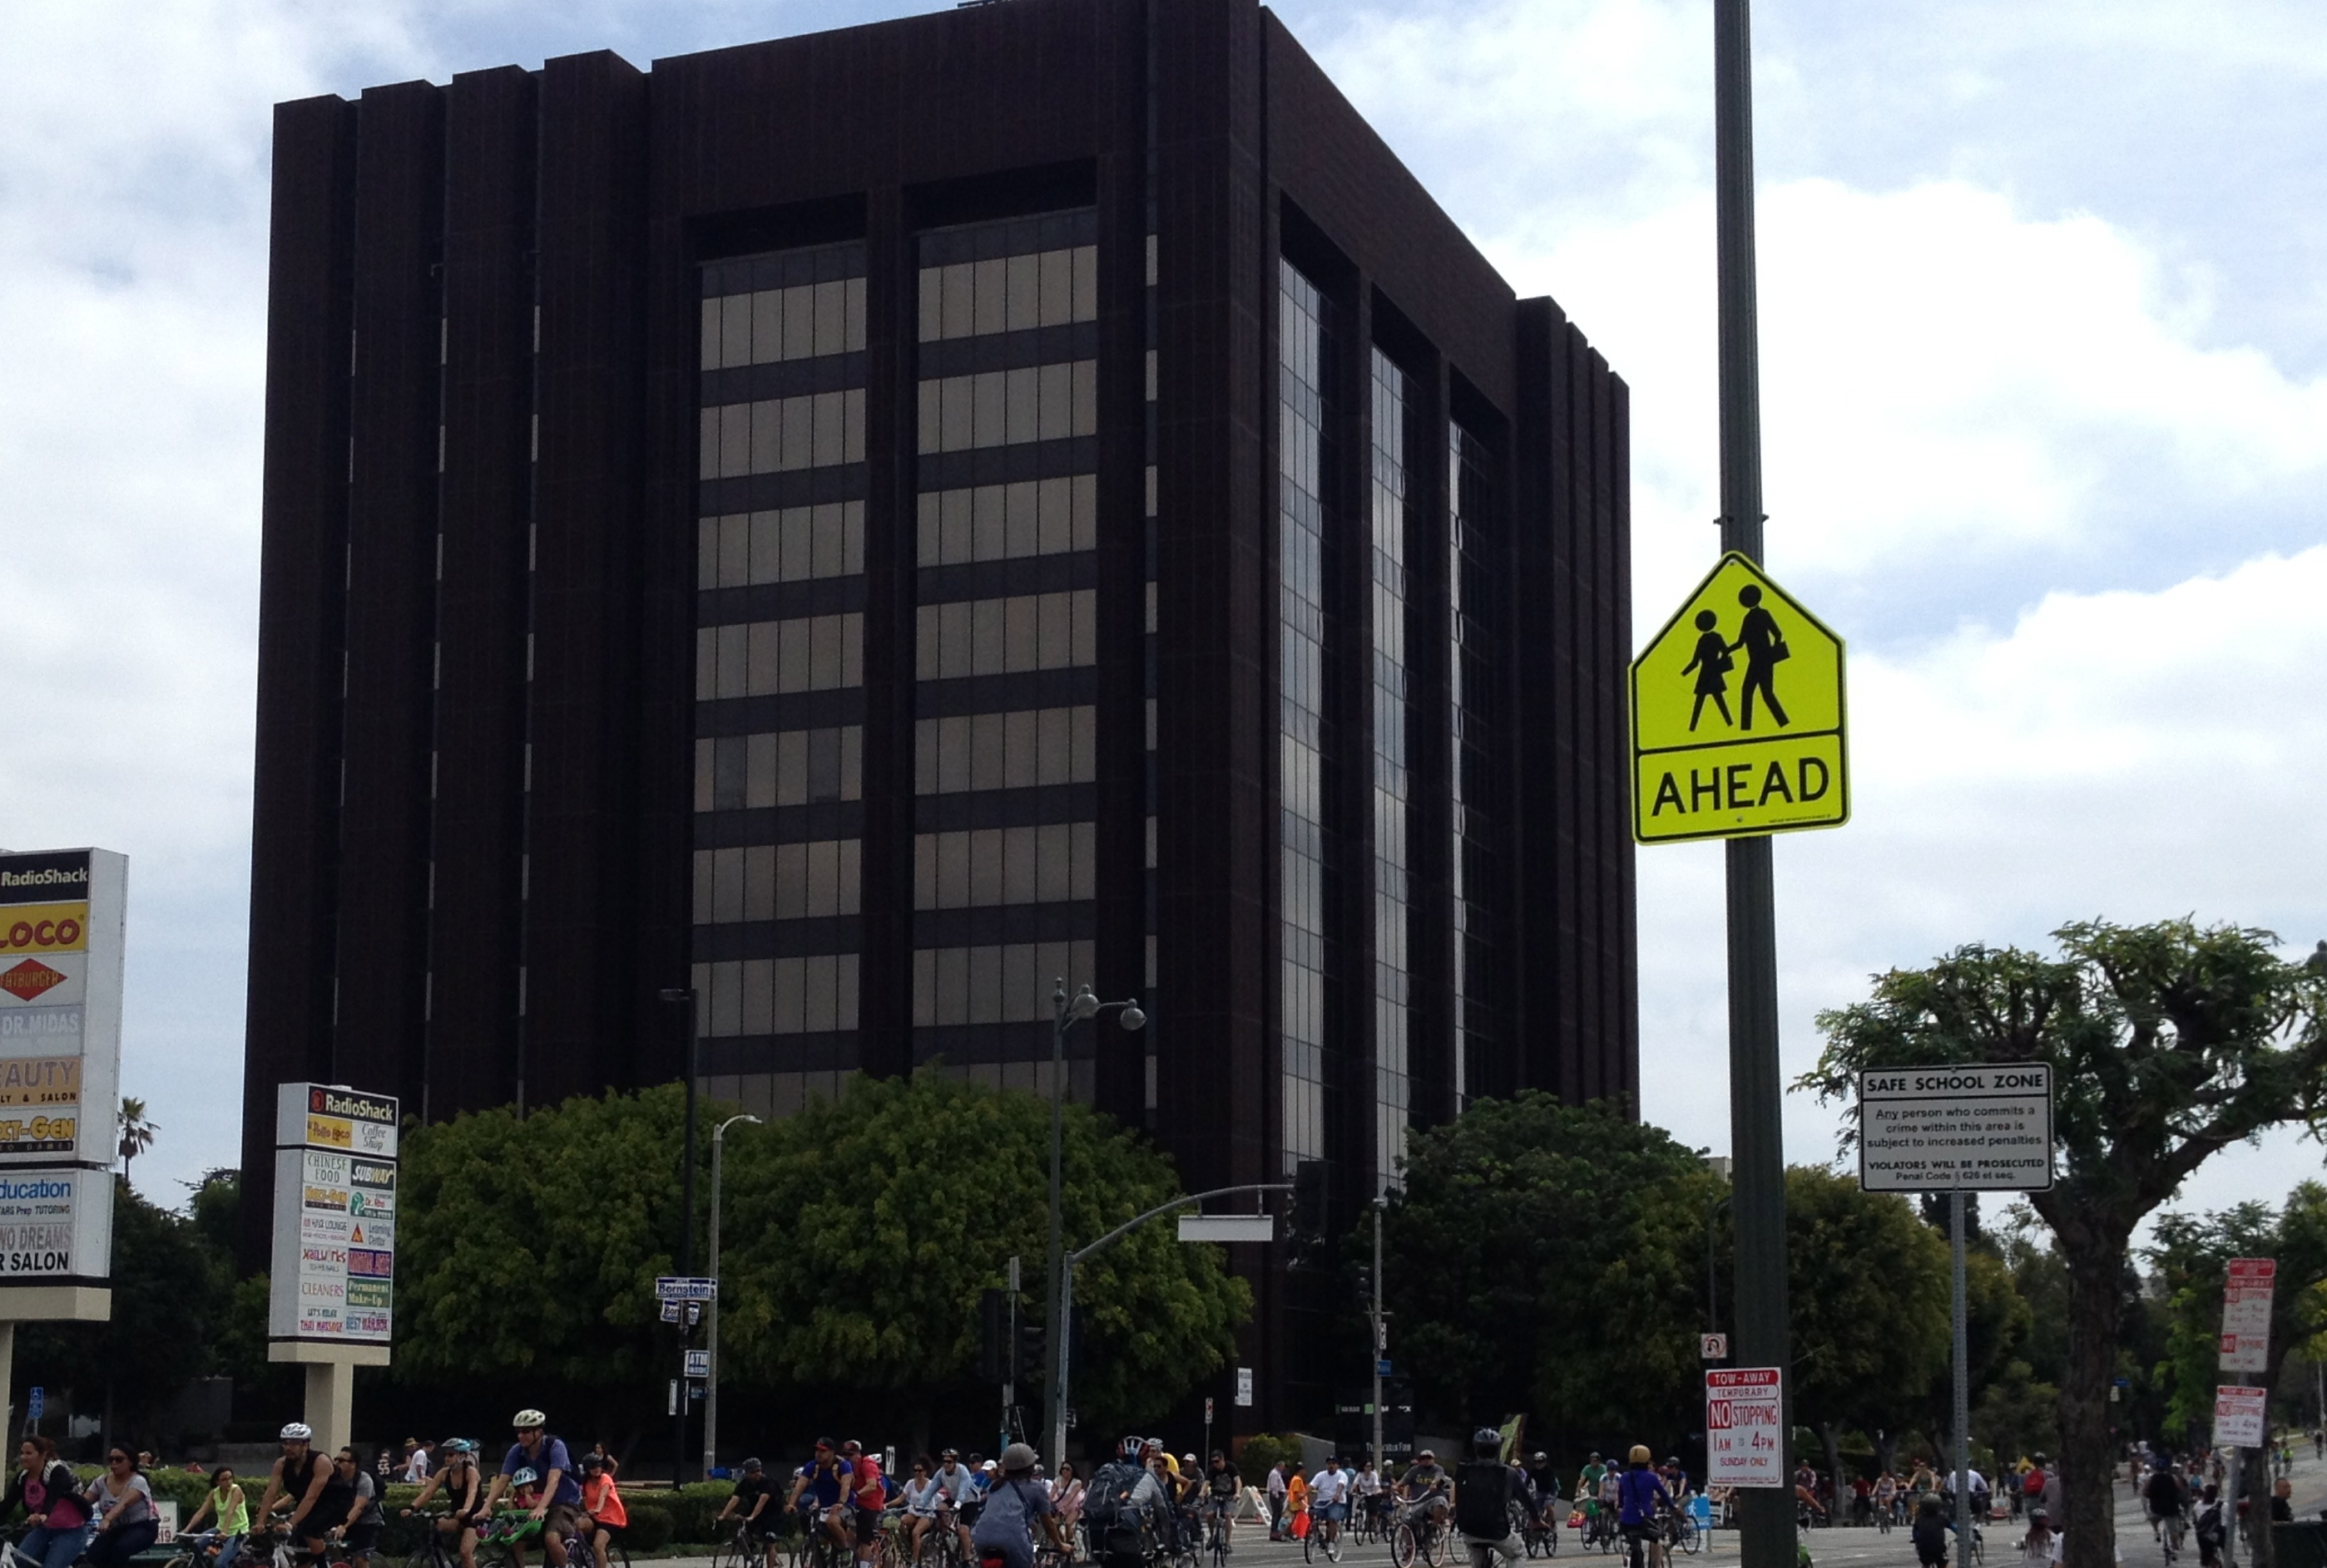

Dr. Muhlheim@gmail.com

www.LaurenMuhlheim.com

+1-323-282-3572

4929 Wilshire Boulevard

Suite 245

Los Angeles, CA 90010

# On August 1, my office is moving to

# 4929 Wilshire Boulevard, Suite 245!

# (Only one mile east of my old office)

* **Lauren Muhlheim, Psy.D.**

## Street parking may be trickier than at my old location – please allow extra time before your first visit. The building has underground parking for $4.50 per hour (enter the lot on Highland). There is free street parking on Wilshire.

## For more details about parking near the building, see the website of the ju-jitsu studio located in the lobby: http://www.cobrinhabjj.com/academy/parking

I’m Moving!